**Medical Prescription Using ChatBot**

*Dr. Govinda K*

*[kgovinda@vit.ac.in](mailto:kgovinda@vit.ac.in)*

**Abstract --**

Chat bots are computer programs that mimic conversation with people. They can transform the way you interact with the internet from a series of self-initiated tasks to a quasi-conversation. Today market have lots of medicine for same purpose so every one have not enough memory to remember about medicine. Some times people takes medicine with out advise of any medical expert. So that case this chat bot is very helpful. We have not to go any where just chat with robot and user will get information about medicine. This bot will tell to user for what infection or disease a particular is made . Chat bot orientated for medical prescription will given information about medicine i.e. when we have to take medicine, number of medicine we have to in a day, we have to medicine after or before food, min age that allow for particular medicine, drug or chemical use in medicine, medicine have some side effects or not.

Interestingly, after years of explosive growth, mobile apps have largely [stopped](http://www.gartner.com/newsroom/id/3018618" \t "/home/unknown/Documents\\x/_blank) [growing](http://www.nielsen.com/us/en/insights/news/2015/so-many-apps-so-much-more-time-for-entertainment.html" \t "/home/unknown/Documents\\x/_blank). In the [post-app world](http://www.wsj.com/article_email/a-few-ways-to-declutter-your-phone-1456117380-lMyQjAxMTA2NTI2MjYyMjI5Wj" \t "/home/unknown/Documents\\x/_blank), visionary technology companies, such as Facebook, Microsoft, Amazon, and Apple, are [making](https://chatbotbook.com/microsoft-goes-all-in-on-chat-bots-f64d0fd3e2e0" \t "/home/unknown/Documents\\x/_blank) [huge](https://chatbotbook.com/war-of-bot-platforms-22e02cfa0a99" \t "/home/unknown/Documents\\x/_blank) [bets](http://venturebeat.com/2015/06/25/amazon-launches-an-sdk-for-developers-to-build-new-skills-for-amazon-echo/" \t "/home/unknown/Documents\\x/_blank) on a new user interface paradigm: automated agents in mobile messaging apps, known as [chatbots](https://chatbotbook.com/the-rise-of-intelligent-bots-e896cde7281b" \t "/home/unknown/Documents\\x/_blank). Can chatbots do better than mHealth apps in engaging patients?

**Introduction --**

In the past 8 years, many companies had invested heavily in mHealth applications to engage patients for everything from medication adherence, vital sign monitoring, self-reporting of symptoms, telemedicine consults, and behavior coaching etc. The results have been mixed. Some studies [showed promise](http://www.welldoc.com/images/uploads/Quinnmobile.pdf" \t "/home/unknown/Documents\\x/_blank) while others [fell flat](https://peerj.com/articles/1554/" \t "/home/unknown/Documents\\x/_blank). Even for the ones that showed promise, the studies themselves often require a team of clinicians to follow up with patients to make sure that they use the technology solution on a regular basis. That by itself could defeat the “scalability” of such technologies.

The mediocre performance of mHealth apps is probably rooted in the lack of a truly engaging user experience. The need to install an app, and remember to open the app daily, is a chore, especially as the app reminds people their illness — people like games and entertainment in their mobile apps not sorrow and illness.

Instead of asking patients to open yet another app, good interventions should bring engagement to the patients in communication channels patients already use. In that aspect, the old “non-scalable” nurse home calls are effective because patients already use their phones for phone calls. There is no more app to install and the intervention is “pushed” to the patients without them having to do anything.

Medical prescription opinion chat bot will give you detail about any medicine. This bot will give information according to user query. This can tell what chemical or drug use in medicine, age range, how to take, amount can take per day, medicine have any side effects & medicine is orientated.

**Review --**

Here is sample of chats with bot to get information about some medicine. This picture how bot is responding according to user query. Bot will take your query as input then first remove programming code from the query and then start processing on it and later checking into database for relevant data to query and after that bot will generate sentence for reply and then send to user who send the query.

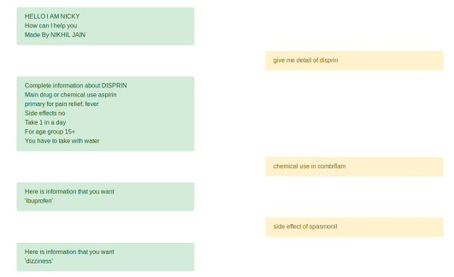

**Software Components :--**

For this proposition, software components need not be manually integrated with website that have database of medicine details.

* Nodejs with express, body-parser, ejs, cookie-parser, compression, express-sanitizer, helmet, morgan, mysql
* Webstorm
* Mysql server
* SSH operable terminal with root access

**Proposed Method --**

Let’s know what happening at server side. How this chat bot is working. This chat bot is working without any AI or machine learning concept. String(query by user) receive at server is take as root and then words present in this string will be child of root then for the checking for particular word of query then according to that we make sql query for and retrieve data from data base and generate sentence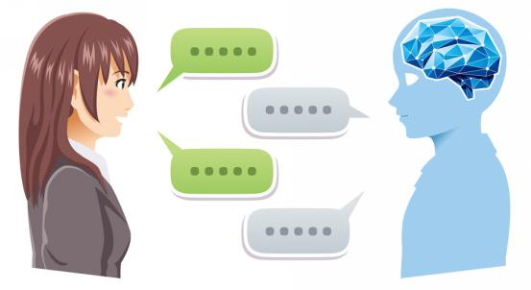

and send to client. If data is not present in data base then chat bot will say to user to try with some different way.

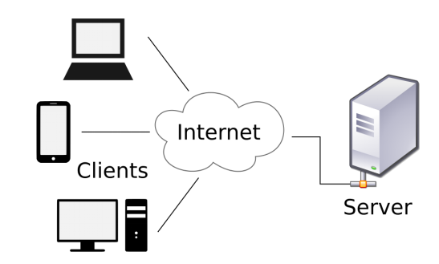

Above picture will show communication of between chat bot on web server and different devices. This web based chatbot can provide service on different devices have internet connection & perform browser servicing like laptop, desktop, mobile & tablet, smart TV.

**LITERATURE SURVEY :-->**

There are very few chatbots available in the health care industry. Because, building a chatbot for health care requires immense knowledge on how the health care industry works.

Generally[1], it takes about three main processes to generate an output from a user‟s input. The processes include

1. Normalization process, where input query is being normalized into standard form by removing unwanted symbols and words and synonyms replacements,
2. 2) Matching process, is where input query are being matched with the keywords from the database, and lastly
3. 3) Generate Response process, that correspond to the Responses database reflected according to the matched keywords. There are four tables are involved in this architecture. Root words and Synonyms tables to be uses in input normalize process, Keywords table to be used in keyword matching process, and Responses table that store every possible responses.

For the flow of whole process, it started with an user‟s input, then chatbot will perform Normalization onto the input query while interference with the Root words and Synonym table. Normalized words will be sent to Keywords Matching for matching process with the Keywords database table. This process involve OMAMC (One-Match and All-Match Categories) technique. All results have their own Match ID, then it will be sent to Select/Generate Response process where Responses database will execute the response which is associated with the Match ID back to the process as the final output. While in author context, author can perform add, edit, or delete action onto the database system.

In present market bot is come with advance feature like AI, machine-learning based model and in[2] an internet-based communication paradigm that relays its foundations in the social network era. Healthcare, and in particular eHealth, can benefit from this model since it strongly requires a human-like interaction schema. A chatbot (also known as a talkbot or chatterbot) is an artificial entity able to autonomously hold a conversation via message exchange. With progresses in machine and deep learning, nowadays chatbot can be very reliable and able to provide automatic and adaptive human-like conversation behaviour, getting in-volved in several application fields including customer services or data collection.

**Results --**

The average person uses 3–5 apps per day and the big app purge is coming… You know the day, you delete all of those apps that you don’t use.

In a really big way, apps have failed us and the reason is quite obvious: attention.

Simply put, we humans do not have enough bandwidth to consume all of the great content available to us. We can not read all of the great books, watch all of the best movies, listen to every amazing song and utilize every piece of technology. To do so would be humanly impossible!

As a result, only a handful of apps have risen to the top and occupy valuable mind estate and these are the apps we use everyday. The other 99.99% of apps are sitting on the sideline, their tech goes unused.

Medical prescription opinion chat bot made on node js & mysql as data base engine, express as java script library for creating sockets & handle request, response.

**Conclusion --**

Bots user experience is ultra fast and simple. In fact it is so simple, that it might be comparable to picking fruit from a tree -something humans have been doing for 100K years+. No matter what fruit you are picking, the user experience is similar while the reward is different.

One of the main advantages with bots is that they offer instant access to value while eliminating friction. There is no sign in or sign up process, like an app or a website, and since the bot already has access to you social profile it can personalize information to you instantly.

Bots tail will have far more value than Apps’ long tail. In terms of popularity, the tail will both be much longer and have a higher volume. Bots will be more comparable to websites or even phone calls than apps.

The internet allowed us to democratize content and product creation. As a result, artists, bloggers, musicians, product creators are no longer at the whims of large corporations. Solo acts have access to distribution channels like never before and Bots offer a logical next step.This means further democratization for product and content creation and an even bigger push towards personalization.

This type of chat bot will helpful to user to get detail of medicine in very convenient manner. In present time number of people like to chat with some one. In same manner this chat bot will give you detail. We can chat by any browser with any device (either mobile , tablet or PC or smart tv).

**References --**

1. PATIENT'S CHATTING MECHANISM by LEE SIM SIEW
2. Chatbots meet eHealth: automatizing healthcare by Flora Amato, Stefano Marrone, Vincenzo Moscato,Gabriele Piantadosi, Antonio Picariello, and Carlo Sanson

***Made by Nikhil Jain(17BCE2250)***